SDD Workflow
https://arxiv.org/pdf/2602.00180
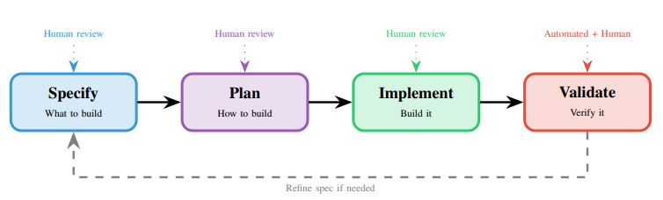

This figure indicates the workflow that an organization will follow in order to implement proper Spec Driven Development. There are 4 phases shown above. Phase 1 is to specify the spec, this is the initial setup of the Spec. This sets the spec up like a user story and should outline how the user is going to interact with the planned feature. Phase 2 is to plan how the feature will be built and outlining technologies and services to be used in implementing the feature i.e. “Use Postgres for database use, access these API endpoints”. Phase 3 is implementation; this can be automated by AI to build the feature by utilizing the Spec provided. It is recommended to break these requirements from the Spec into smaller chunks and reviewable tasks. Phase 4 is validation. This is where both test scenarios defined by the spec and developer orchestrated testing will validate that the feature is maintained in its scope and maintains accepted performance metrics and outcomes.

